Phugtal Monastery in Zanskar Valley – Ladakh

**Phuktal Monastery** or **Phuktal Gompa** (often transliterated as **Phugtal**) is a [Buddhist](https://en.wikipedia.org/wiki/Buddhism) [monastery](https://en.wikipedia.org/wiki/Monastery) located in the remote Lungnak Valley in south-eastern [Zanskar](https://en.wikipedia.org/wiki/Zanskar), in the [Himalayan](https://en.wikipedia.org/wiki/Himalaya) region of [Ladakh](https://en.wikipedia.org/wiki/Ladakh), in [Northern India](https://en.wikipedia.org/wiki/Northern_India). It is one of the only Buddhist monasteries in Ladakh that can still be reached only by foot. Supplies to the monastery are brought on horses, donkeys, and mules in the warmer months, and in the frozen winters, they are transported through the frozen [Zanskar River](https://en.wikipedia.org/wiki/Zanskar_River). A road is expected to be built up to the monastery, however, for now, it is a day's walk from Village Cha or Village Khangsaar, the end of the road leading from [Padum](https://en.wikipedia.org/wiki/Padum" \o "Padum). The Phugtal monastery was Solar powered up in 2016[[1]](https://en.wikipedia.org/wiki/Phugtal_Monastery#cite_note-1) with a team of Global Himalayan Expedition (GHE) members.

History

The Phuktal Monastery is built around a natural cave, which is believed to have been visited by numerous sages, scholars, translators, and monks around 2,550 years ago. The remote location of the monastery was ideal for monks looking for peace and solitude to meditate.

1ST image:

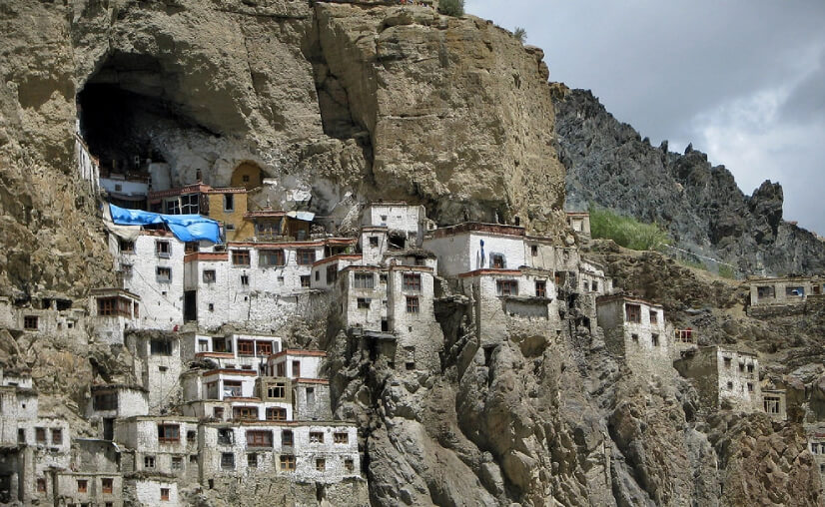

<https://www.tourmyindia.com/states/ladakh/imagess/phuktal-monastery2.jpg>

2nd image:

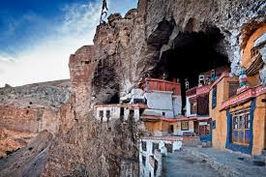

<https://encrypted-tbn0.gstatic.com/images?q=tbn:ANd9GcRiuNz8Gt13gh0TiPMZ16anYG0m7Rh0agq9Zg&usqp=CAU>